- Create on Bash script to check if a directory is available or not.

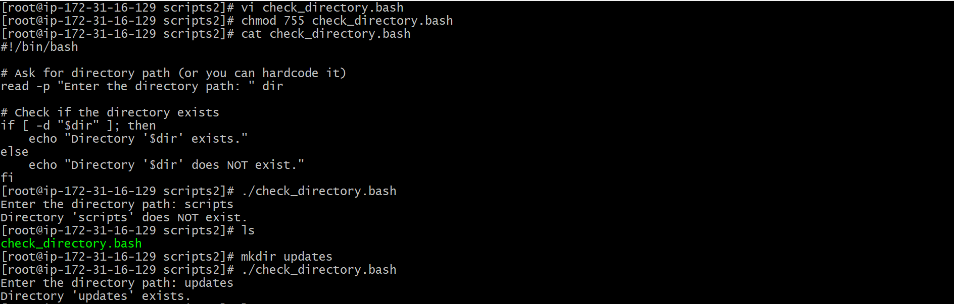

- Create a bash script which will create multiple files.

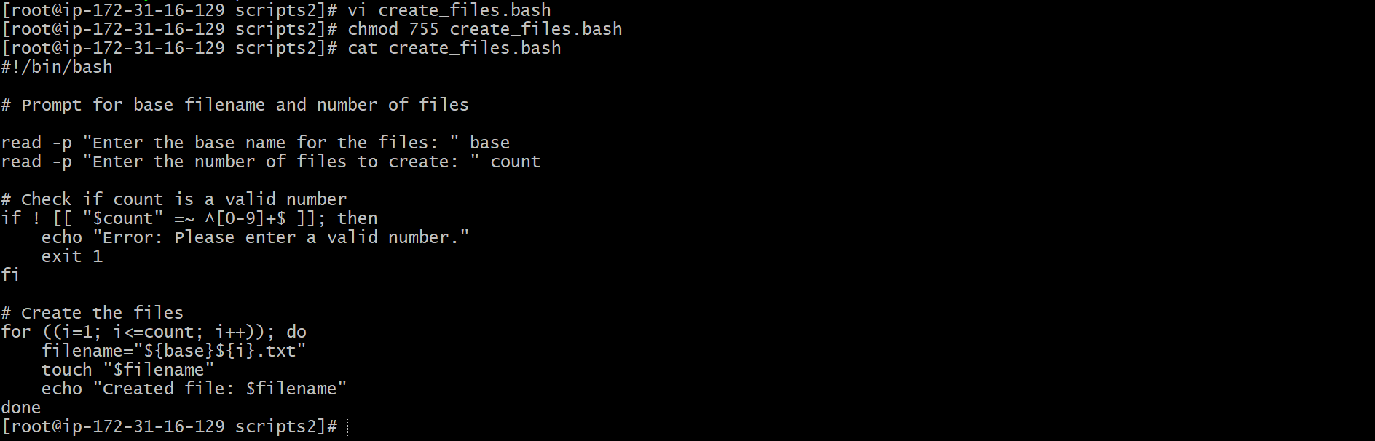

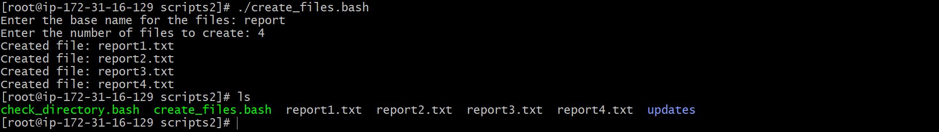

- Create a bash script to take backup of a directory.

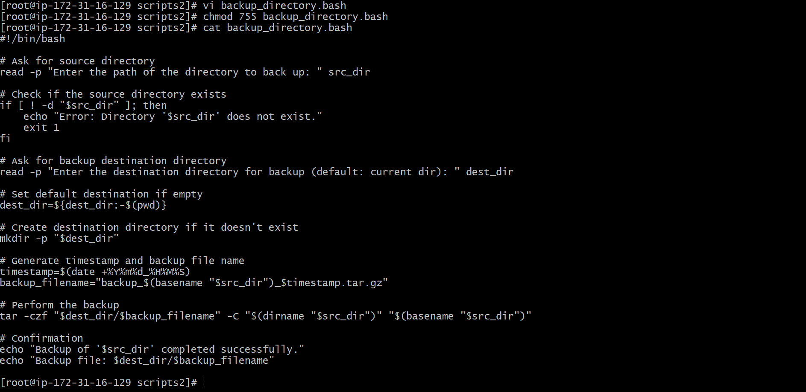

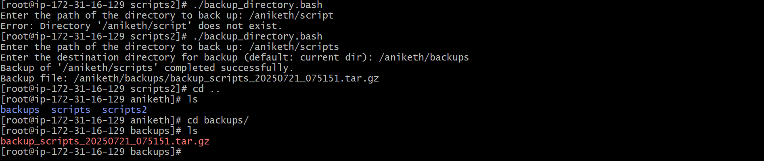

- Create a bash script to install nginx in ec2 server.

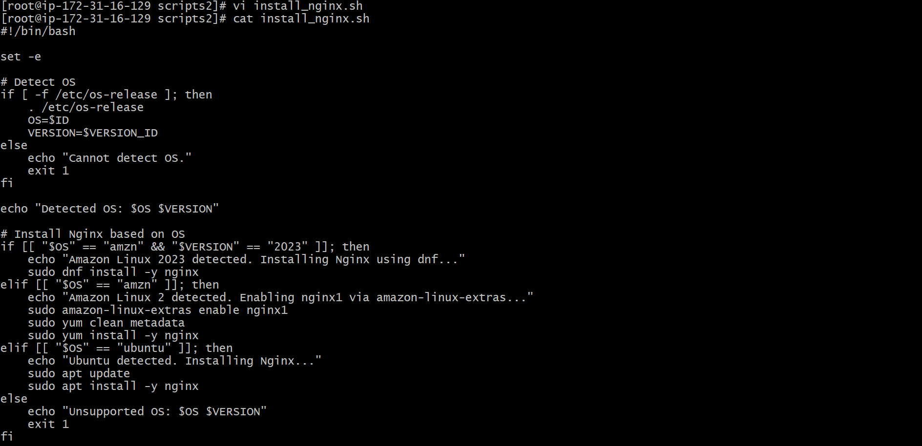
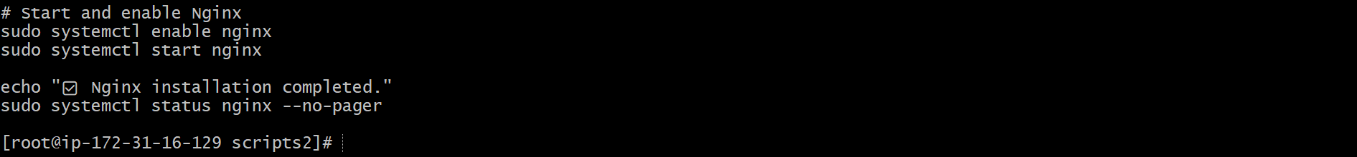

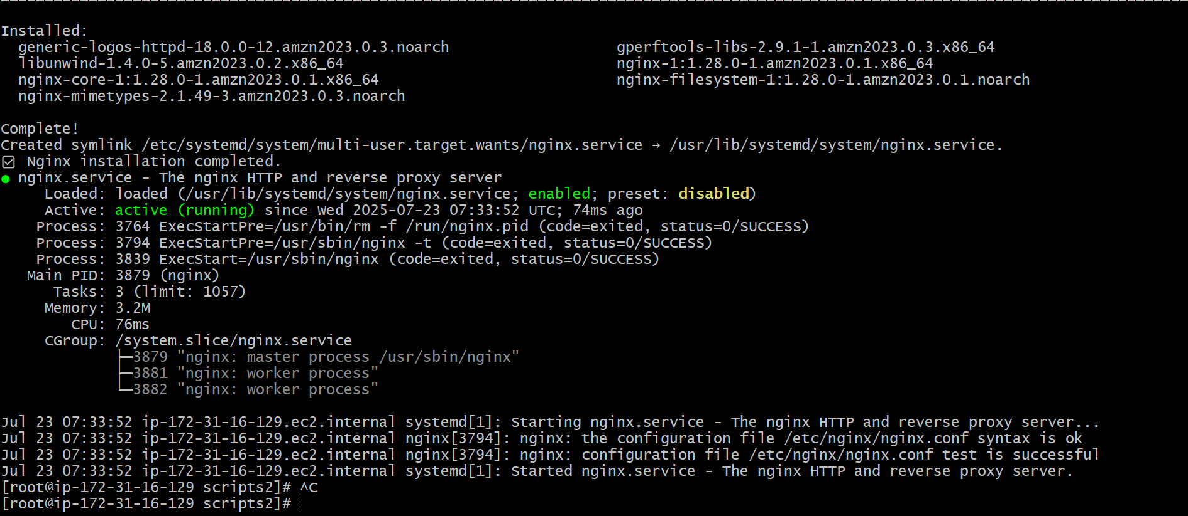

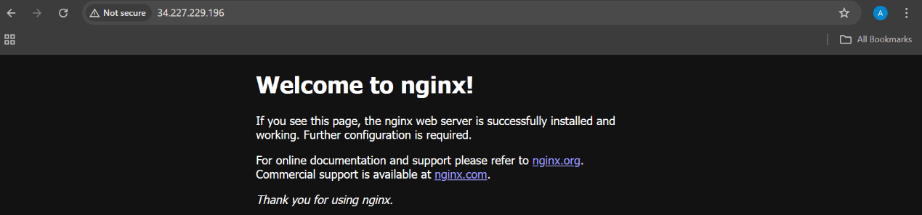

- Create a bash script to install ApacheTomcat in ec2 server.

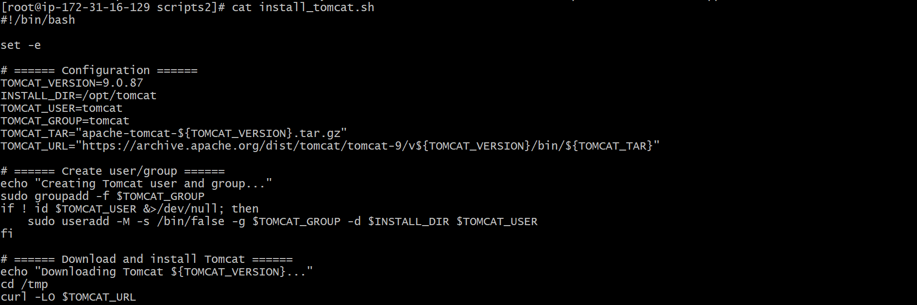
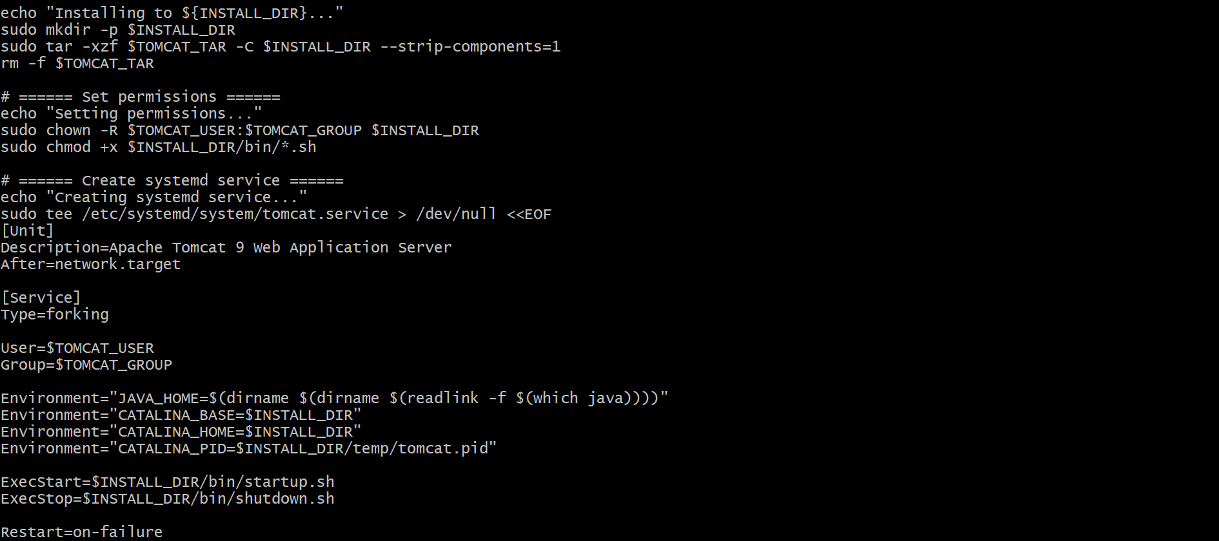
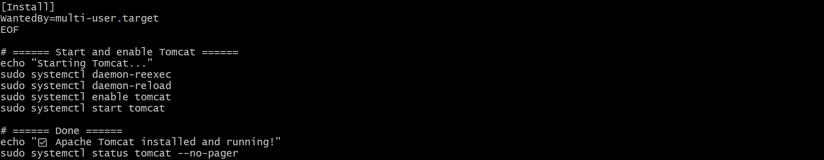

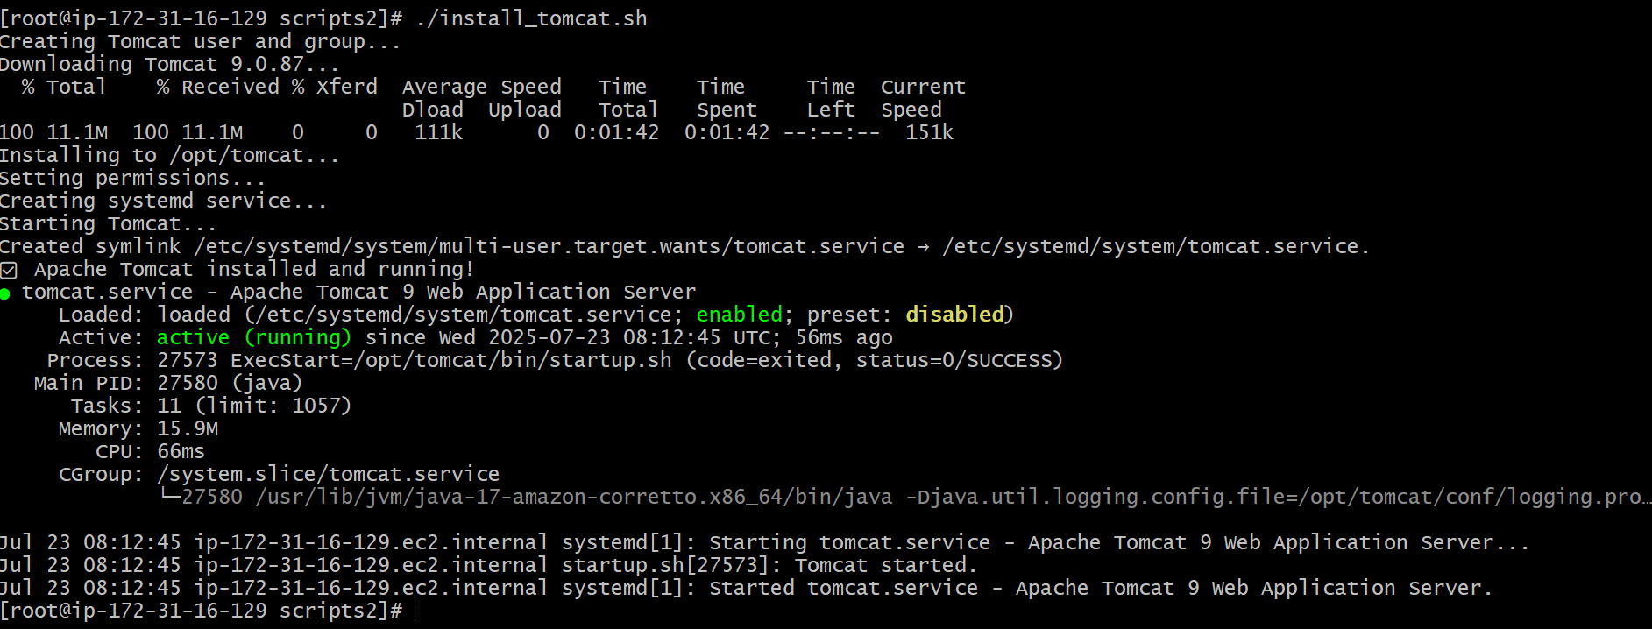

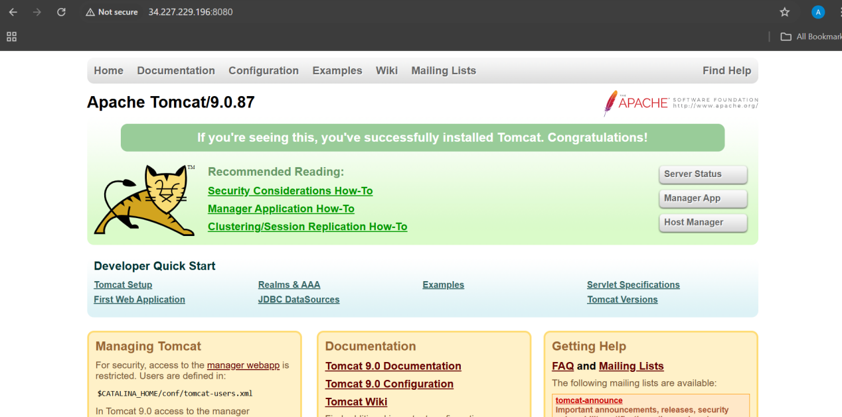

- Create a bash script to check list if nginx service is running or not,if not running then script should start the service.

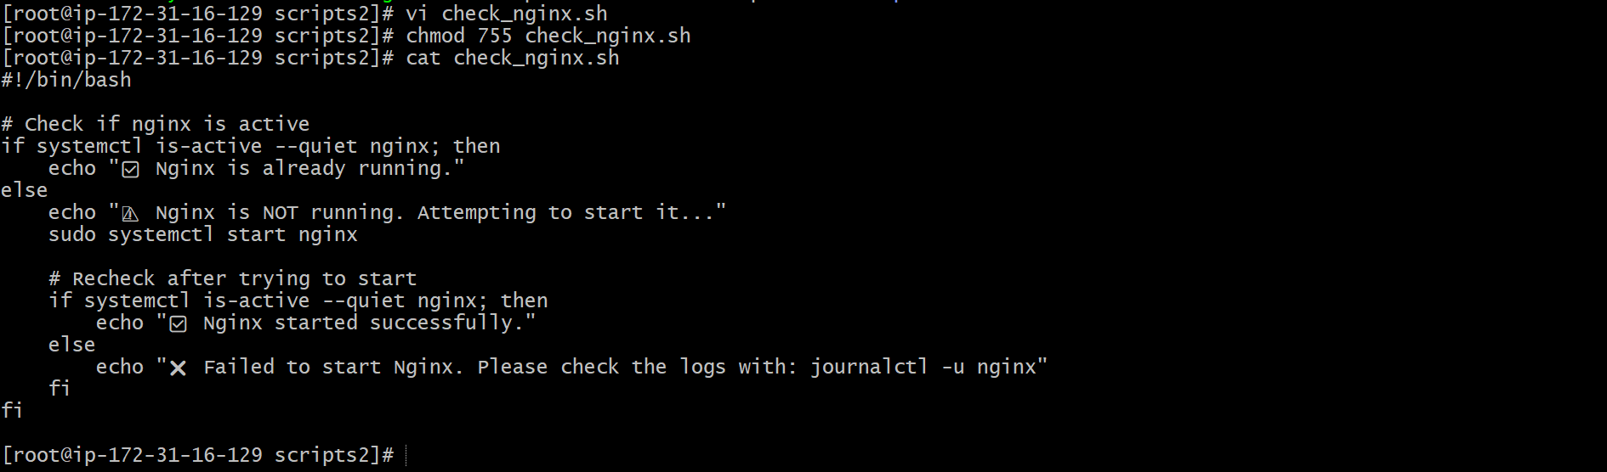

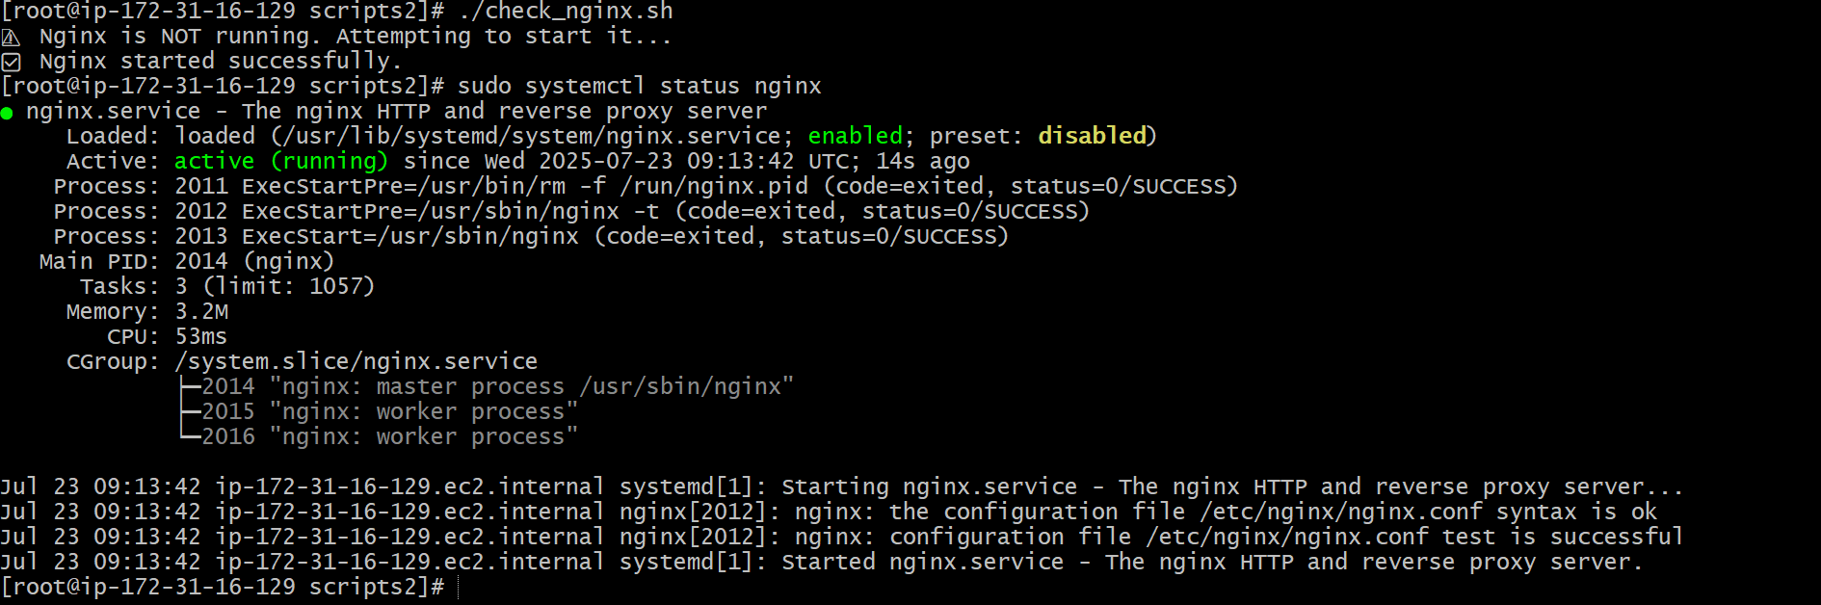

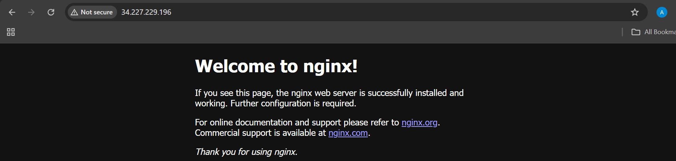

- Create a bash script for calculator.

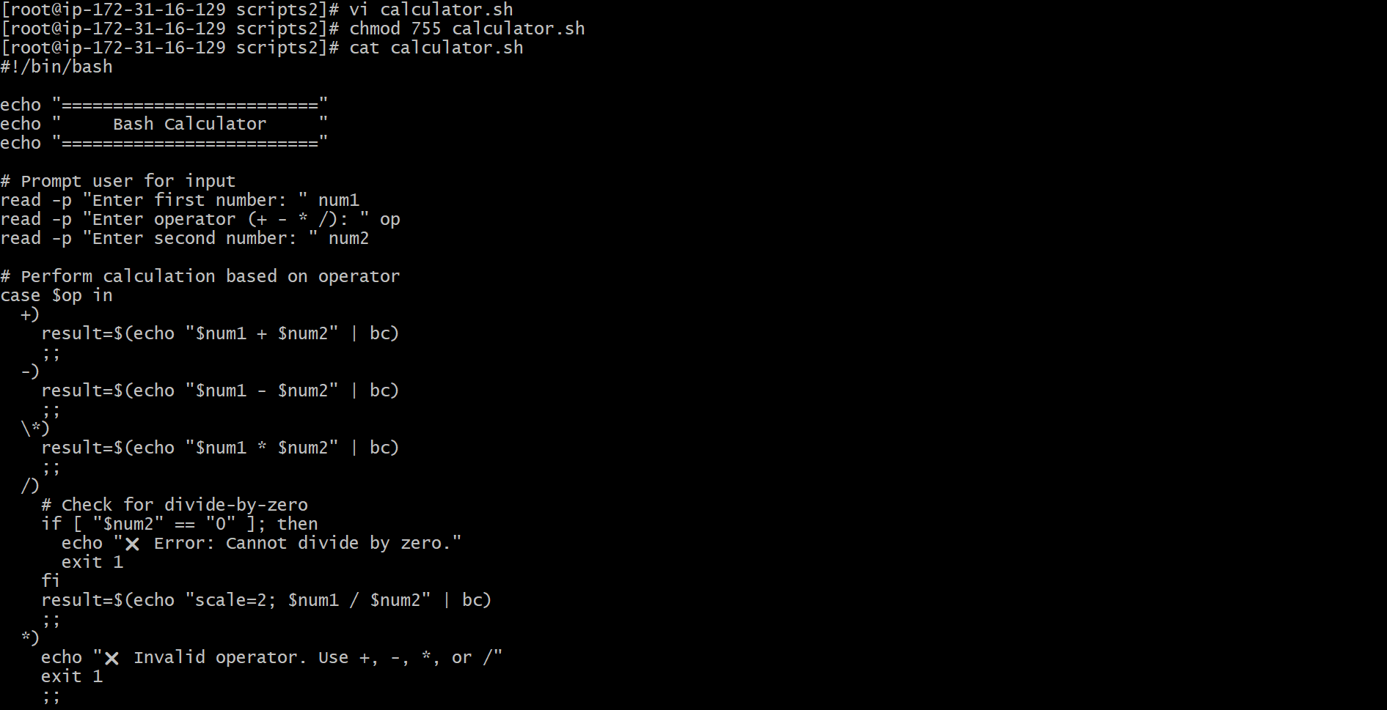
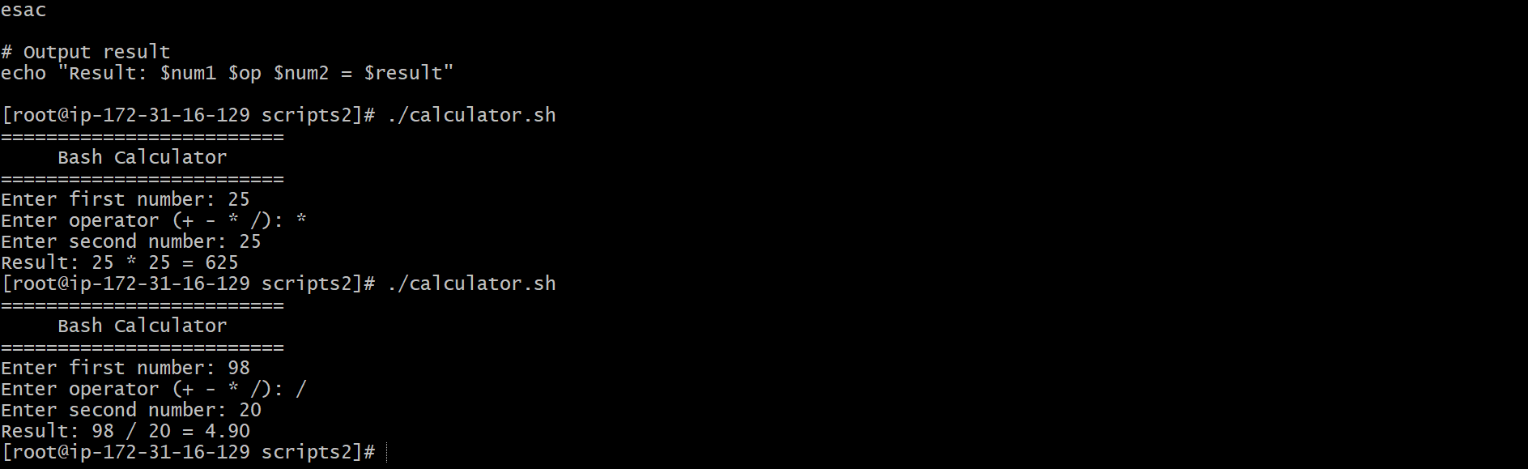

- Create a bash script to check if directory is avaialble or not,if not then create a directory.

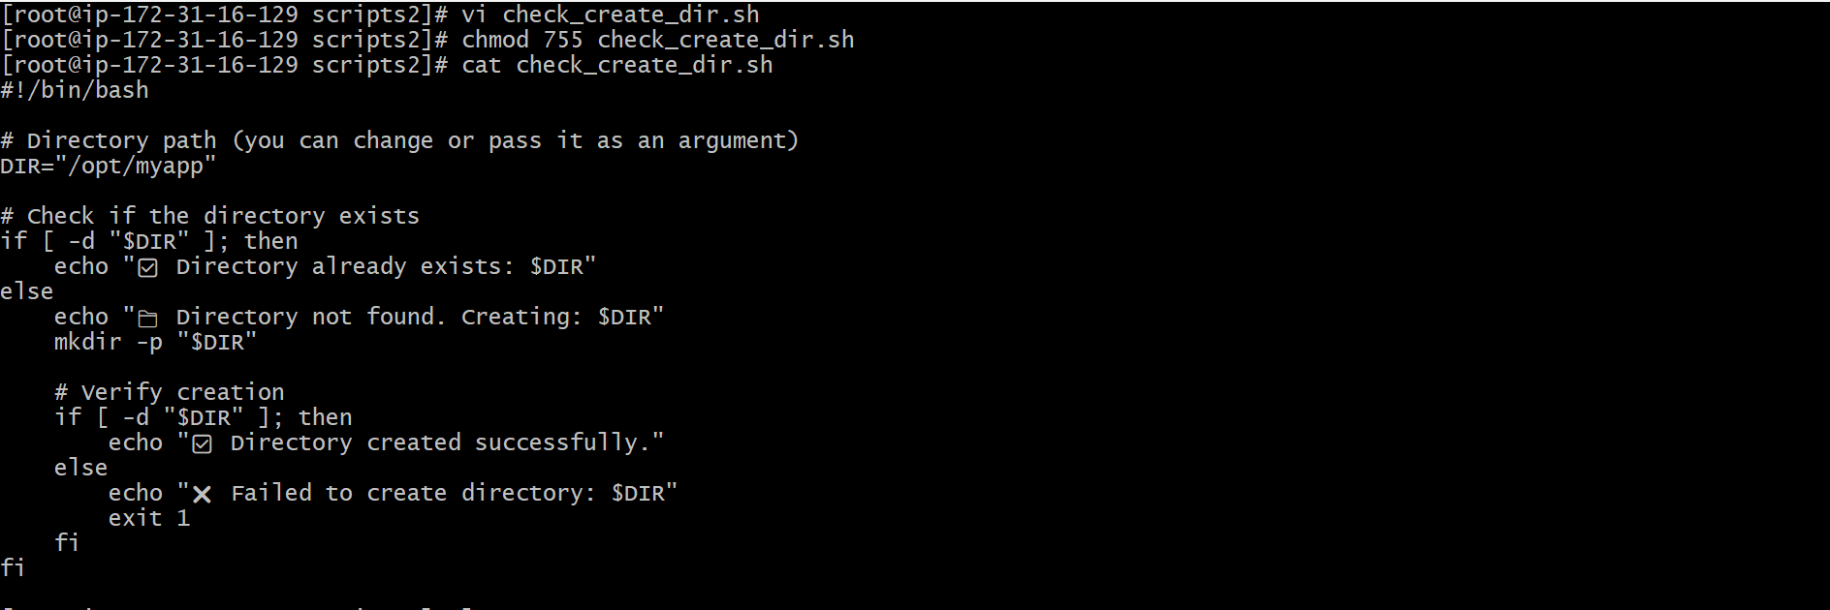

Scene 2

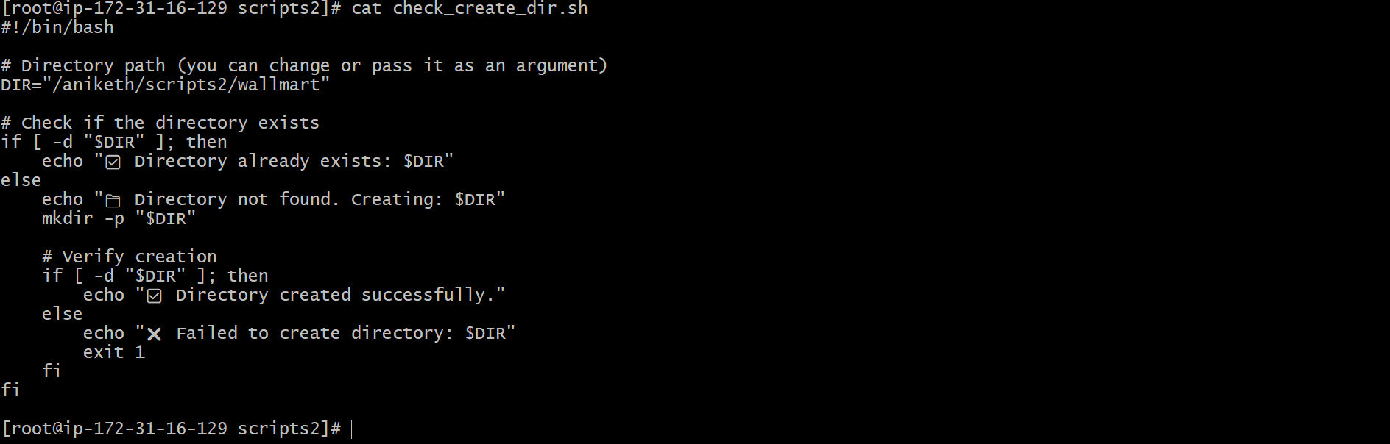
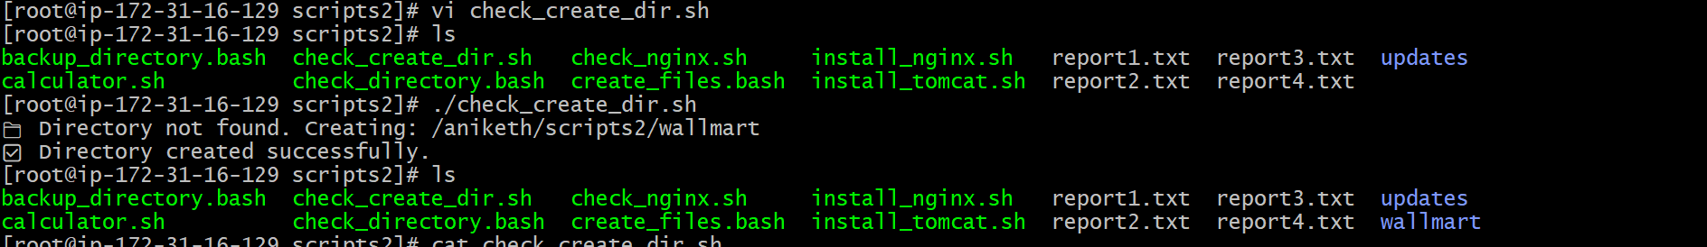

- Create bash script to delete last 3 lines for a file.

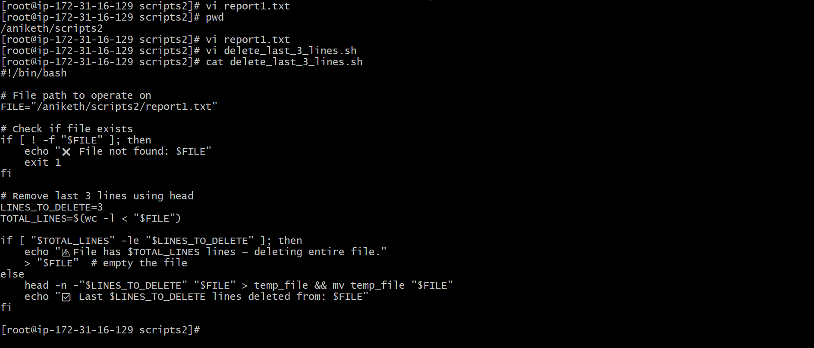

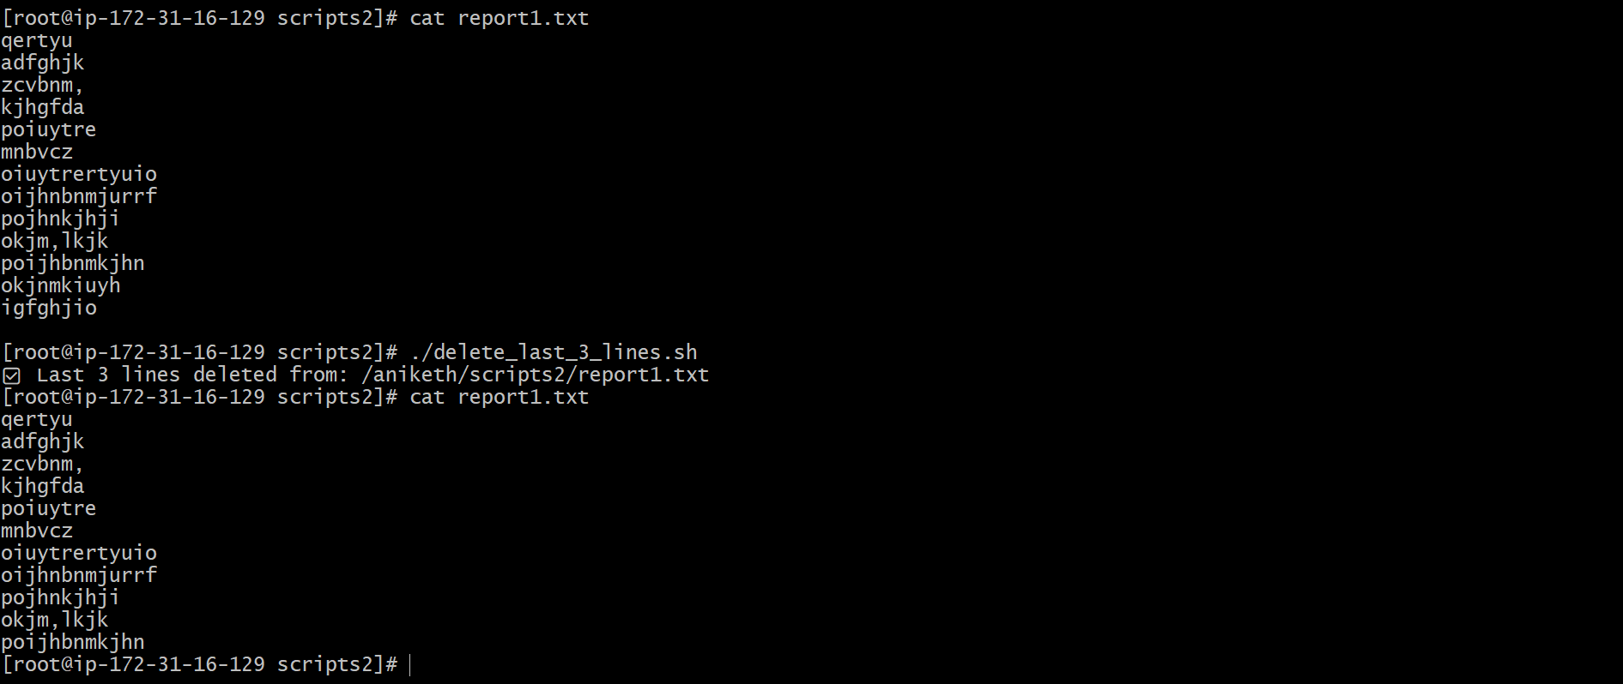

- Bash script to monitor cpu and if it is more than 80% then send email notification.

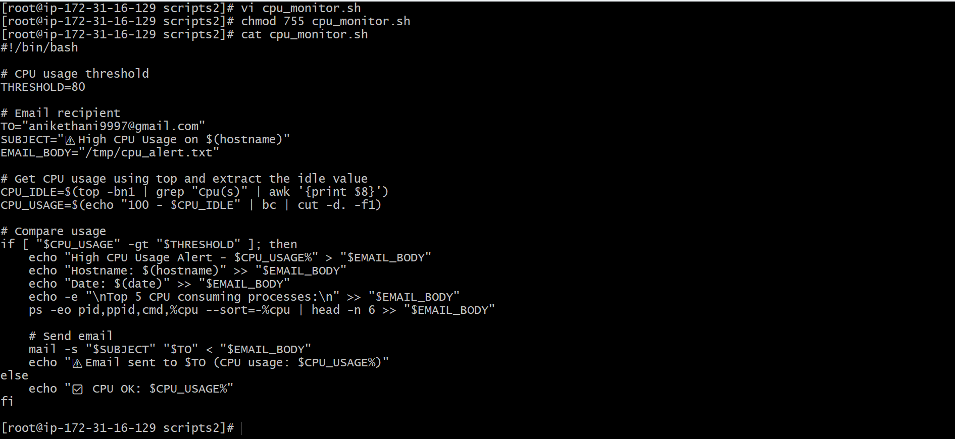

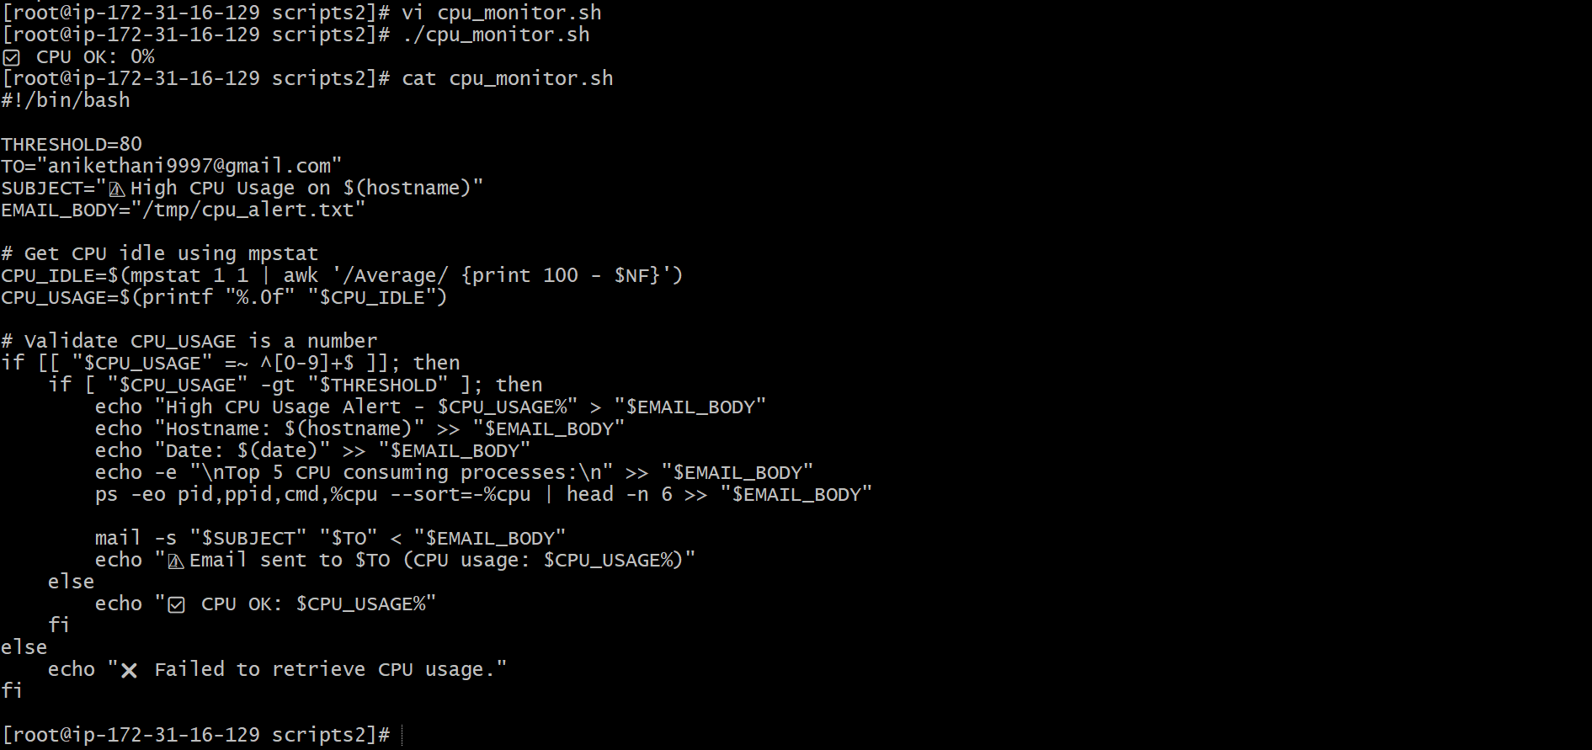

- Bash script to monitor disk space and if it is more than 80% then send email notification.

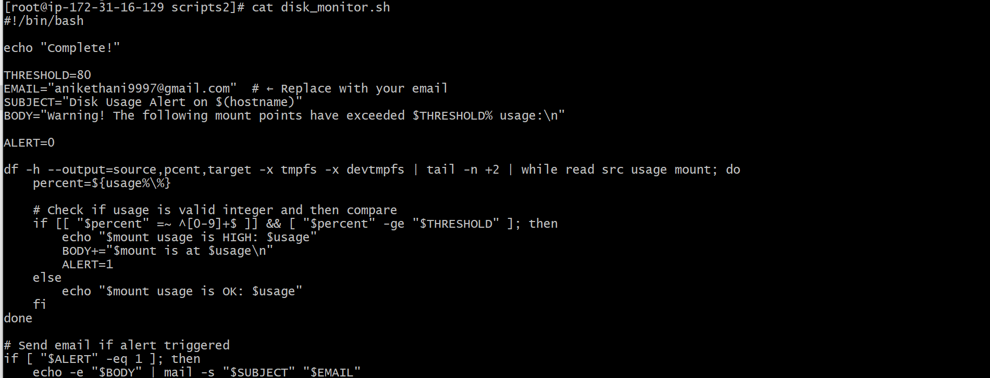

- Bash script to monitor memory and if it is more than 80% then send email notification.

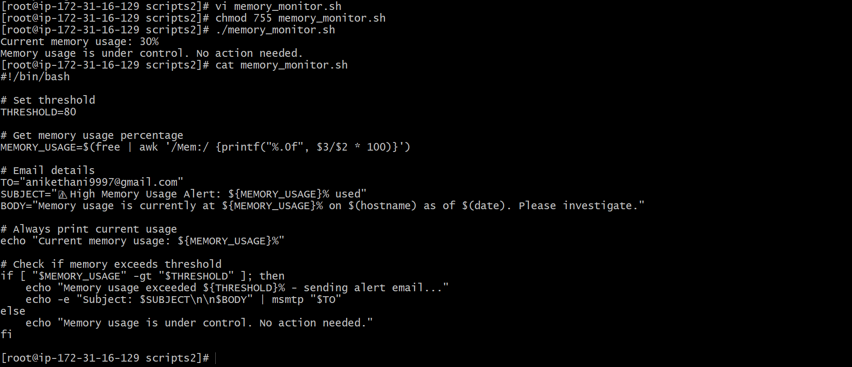

- Exercise Crontab Entries :
1) April 5th Midnight
2) 5 th of Every November,Jan,June if it is a Thursday.
3) At 05 and 27th minutes of 9,10,11 hours everyday.
4) 34 min. of 9th hour on 15th Aug.
5) Every midnight
6) Every Weekend ( Saturday night 11.59 )
7) After every reboot
Note:
1) All the Scripts needs to be executed on Amazon Linux Ec2.
2) Document all the task and also push the task to github reposiroty.
3) Share the document and github Repo url once done for evaluation in
dvps-cloud-status channel.

